Domini Canis
10 Dominican Saints and Blesseds

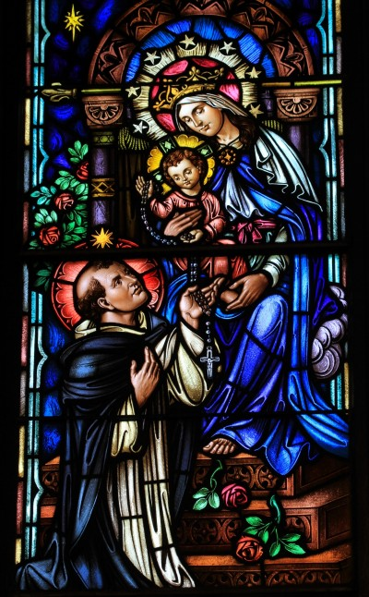
Saint Dominic de Guzman
Founder of the Order of Preachers
Born: 1170, Died: August 6 1221
Attributes: Star on the forehead, Dog with lit torch, Book, Lilies
Biography
He was the younger son of Felix de Guzman and Juana de Aza, and the younger brother of Bl. Mannes de Guzman. At the age of 6 years Domingo has his first contact with the clerical life receiving instructions from his uncle the archpriest in Gumiel de Izán. At the age of 24, Domingo began his studies of theology in Palencia and develops as a teacher. At 31 years old, he is a canon of the cathedral of Osma.
With 44 years of age, he travels to “Las Marcas” to arrange the wedding of Prince Fernando in the company of Bishop Diego Acebes. On this trip, Domingo has a first contact with the heretical movements in the South of France. A year later, He preached against the heresy in Languedoc, Montreal, Fanjeaux, among others.
In 1206, he makes his first foundation, the Dominican nuns in Prouille. 8 years later, he founded the first house of the Order of Preachers in Tolosa. That same year, Saint Dominic travels to Rome to attend the Council IV of Letrán. He is accompanying Bishop Fulco de Tolosa.
At this moment Dominic already had the desire to found the Order therefore he presents his project of foundation and requests the approval of Pope Innocent III. In 1216 the church of San Román served as the first headquarter of our Order. In this convent, Dominic followed the mandate of the Pope to adhere to an approved rule and he chose the rule of St. Augustine.
The Order of Preachers is confirmed on December 22, 1216 by Pope Honorius III. He refers to the sons of Dominic as "athletes of the faith and true lights of the world". On August 15, 1217, Dominic sent his friars around the world to preach and found convents. They are established in the following years in cities such as Toulouse, Paris, Rome, Bologna, among others. The first General Chapter is celebrated in Bologna.
Dominic died on August 6, 1221 in San Nicolás, Bologna. He promises his friars to be present among them and to intercede for them from heaven. His remains were transferred to Bologna on May 24, 1233. On July 3, 1234 he was canonized by Pope Gregory IX.

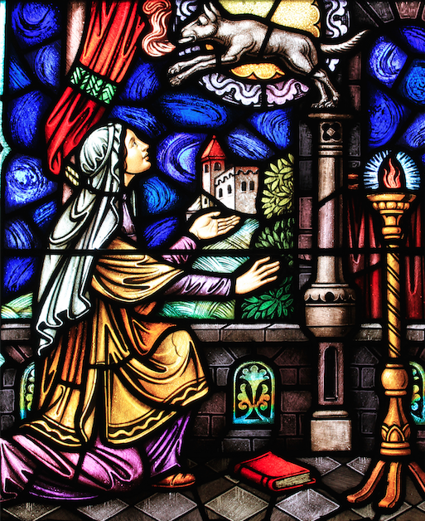

Blessed Jane of Aza
Laywoman, Mother of Saint Dominic and Blessed Mannes de Guzman
Born: 1135(?), Died: Beginning of the 13th Cent.
Attributes: Book, Three children listening, Medieval Spanish Aristocratic Dress

Biography
It is said that before the birth of Dominic, Blessed Jane beheld a vision in which she saw her son , running as a swift greyhound through the world, bearing in his mouth a torch with which he illumined the world (The son became the founder of the Order of Preachers, known as the Dominicans thus the prophetic dream was fulfilled as the Dominican friars took the light of the gospel throughout the world. They became known as the Dogs of the Lord. In Latin the word Dominican would be Domini Canes, literally Dogs of the Lord).
It was for her to fan and shelter that flame at its very kindling, and to teach this child of predilection the prayers he would say with such rich results for a lifetime of saintly action. Not only was it Jane who first taught her son the words of the Hail Mary- that key with which he unlocked heaven for so many souls – but it was she that gave to him the living example of Christian womanhood. If in later years his sons were to cherish such a chivalrous love for the gracious Queen of Heaven, much of it was due to the reverential awe and tender love with which this truly Christian lady inspired her three priest-sons. to every priest, his own mother is the personification of all that is good and lovable in woman; she is the ideal to inspire him, the lighthouse to beckon him, and the living picture of the Mother of the first Priest.
It could have been no different for Dominic. Where else would he , brought up amid the scenes of war and the mans world of thee university, see in action the ideals of womanly purity, gentleness, and never failing help that he was to cherish as the attributes of his heavenly Queen?
History is silent regarding events in the Life of Blessed Jane. probably there were no great events to record. As the wife of the Castellan of Calaruega, a fortress castle on the border of Christian Spain, she would have led a life filled with the monotony of small things. Tradition relates that her two older sons, Anthony and Manez, were already preparing for the priesthood when Dominic was born. She named her youngest son for Saint Dominic of Silos, at whose shrine she was frequent pilgrim . Knowing that her solider/husband expected their third son to carry on the family name and fortunes, Jane seems still to have cherished for him the goal of the priesthood. Very likely Dominic- and we – owe to his understanding Mother the fortune that placed a book in his hands instead of a sword.
Pope Leo XII beatified Jane of Aza in 1828. Devotion to her has persisted through the centuries despite the poverty of records. The mother of three priest, one of whom died a death of heroic charity and two who were raised to altars of the Church, can safely be judged to have been not only a valiant woman but also a saintly one. Her picture, as that of any mother, can best be seen reflected in her sons.

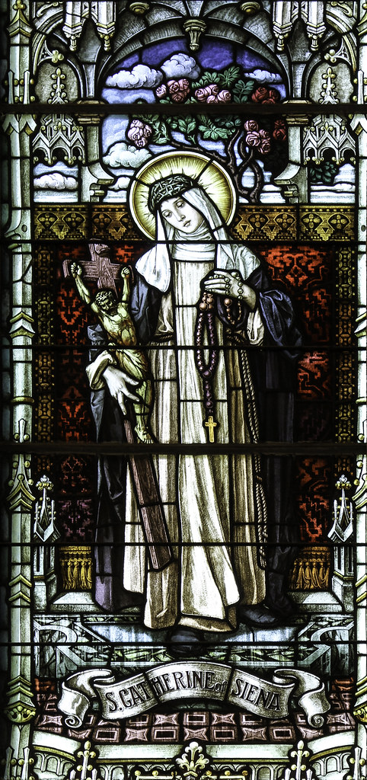

Saint Catherine of Siena
Virgin, Mystic, Lay Dominican
Born: March 25 1347, Died: April 29 1380
Attributes: Book, Lilies, Crown of Thorns, Habit of the Venerable Third Order

Biography
She was the 23rd child of Jacopo and Lapa Benincasa and grew up as an intelligent, cheerful, and intensely religious person. Catherine disappointed her mother by cutting off her hair as a protest against being overly encouraged to improve her appearance in order to attract a husband. Her father ordered her to be left in peace, and she was given a room of her own for prayer and meditation.

She entered the Dominican Third Order at 18 and spent the next three years in seclusion, prayer, and austerity. Gradually, a group of followers gathered around her—men and women, priests and religious. An active public apostolate grew out of her contemplative life. Her letters, mostly for spiritual instruction and encouragement of her followers, began to take more and more note of public affairs. Opposition and slander resulted from her mixing fearlessly with the world and speaking with the candor and authority of one completely committed to Christ. She was cleared of all charges at the Dominican General Chapter of 1374.

Her public influence reached great heights because of her evident holiness, her membership in the Dominican Third Order, and the deep impression she made on the pope. She worked tirelessly for the crusade against the Turks and for peace between Florence and the pope.

In 1378, the Great Schism began, splitting the allegiance of Christendom between two, then three, popes and putting even saints on opposing sides. Catherine spent the last two years of her life in Rome, in prayer and pleading on behalf of the cause of Pope Urban VI and the unity of the Church. She offered herself as a victim for the Church in its agony. She died surrounded by her “children” and was canonized in 1461.

Catherine ranks high among the mystics and spiritual writers of the Church. In 1939, she was declared a co-patron of Italy. Pope Paul VI named her doctor of the Church in 1970.

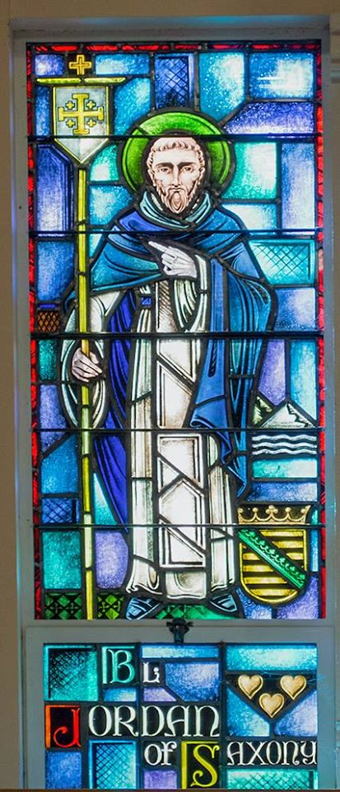

Bl. Jordan of Saxony
Friar, Priest, Master of the Order
Born: 1190, Died: 1237
Attributes: Book, Pen

Biography
A German of noble descent born in 1190, he had been in the Order a mere two years before his election as Master General in 1222. By today’s standards, his rapid accession may appear hasty, a point he himself was quick to highlight when he became the first Provincial of Lombardy in 1221. In the Libellus he writes:
‘In 1221, at the General Chapter in Bologna, they saw fit to make me the first Provincial of Lombardy, although I had only been in the Order one year and had not struck root as deeply as I ought to have done. I was to be placed over others as their superior, before I had learned to govern my own imperfection. I was not present at this Chapter myself.’
Despite his anxiety, he must have made quite an impression on his brothers during his short tenure in the Order. We are told about the type of person he was by those who knew. It is obvious that he possessed all those qualities the ideal leader should have. Inspired by his brother and friend St. Dominic, he was abounding in faith, kind and compassionate, humble, authoritative and yet at the same time understanding. He had the ability to attract people by his sincerity. His style of life complemented his style of words; something that was evidently lacking at the time among the Clergy and Religious. This was vital at a time when ‘reform’ was the buzzword of the day.
His great love for the poor was well known. There is a story said of him that:
‘Meeting a vagabond upon the road who feigned sickness and poverty, he gave him one of his tunics, which the fellow at once carried straight to a tavern for drink. The brethren, seeing this done, taunted him with his simplicity: ‘There now, Master, see how wisely you have bestowed your tunic.’ ‘I did so,’ said he, ‘because I believed him to be in want through sickness and poverty, and it seemed at the moment to be a charity to help him; still, I reckon it better to have parted with my tunic than with charity.’
Our Blessed Jordan may well be still speaking to us today! Not all those people who present themselves as being needy these days may be genuine. However, when we stop caring, we stop striving to be like Jesus. Let us never restrain God’s work in our hearts but allow ourselves to be moved by compassion. Perhaps it was this genuineness that caused Mothers in the district to be wary of his arrival.
Jordan died in a shipwreck on his return from Palestine, where he had visited the local convents of the Order; the shipwreck occurred off the coast of Syria in 1237. As the image above shows, it is perhaps fitting that this great servant of the Order of Preachers, who was kept at arm’s length by the Mothers who feared his magnetic appeal on their sons, should nestle snuggly within the loving embrace of the Mother of God as famously depicted in that famous vision of St. Dominic.

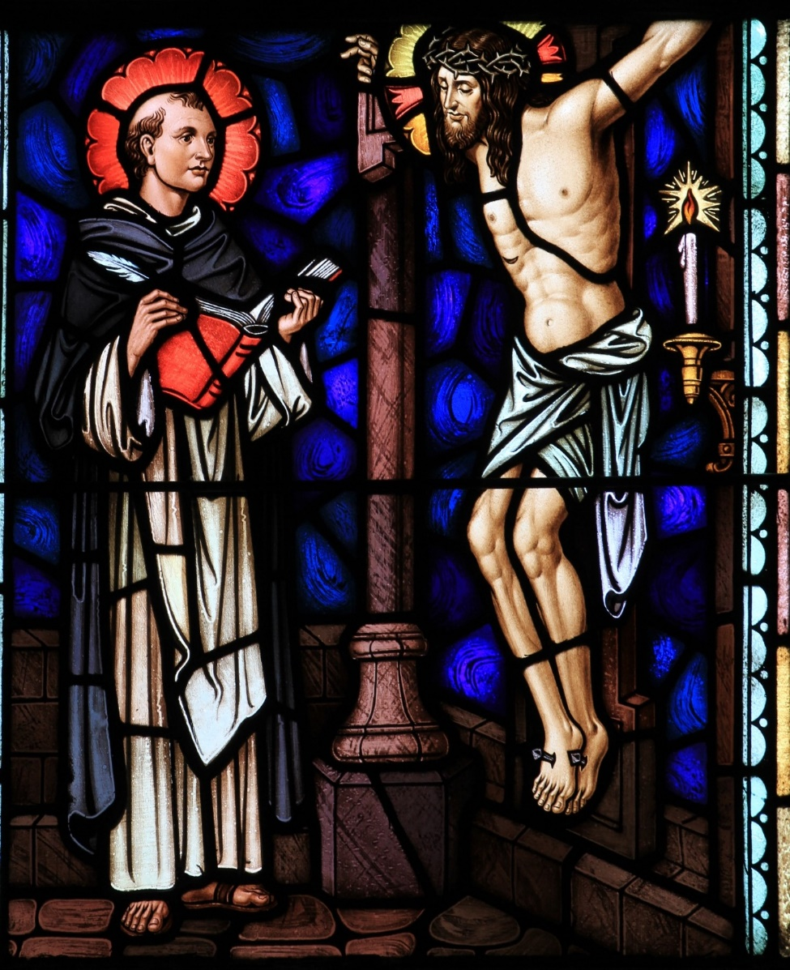

St. Thomas Aquinas
Friar, Priest, Theologian, “Angelic Doctor”
Born: 1225, Died: March 7 1274
Attributes: Brilliant heart, Biretta, Book, Pen

Biography
Perhaps the most well-known and highly regarded theologian and philosopher of the Catholic Church, Thomas Aquinas was born the youngest son to a Sicilian noble family in 1225. Although Aquinas was intended from a young age to become an abbot, Italian political and papal infighting redirected him to a university in Naples, where his studies, including his earliest encounters with Aristotle, were directed by members of the newly founded Dominican Order, an order of which Aquinas eventually became a member despite prolonged, powerful objections from his family.
Traveling to France in 1245, Aquinas continued his studies under the renowned Aristotelian commentator and fellow Dominican, Albert Magnus, before joining the University of Paris’ faculty as regent master in theology, during which time he began work on his Summa contra Gentiles. Upon completion of his regency in Paris, Aquinas returned to Italy in 1259, where he was eventually called to Rome, in 1265, by Pope Clement IV to serve as a papal theologian. While in Rome, Aquinas continued to teach, now at a newly established Dominican school at Santa Sabina, and began to write his most famous work, the Summa Theologiae, sometimes called the Summa Theologica.
In 1268, Aquinas was called once again to serve as regent master in Paris, where “Averroism”—or heterodox Aristotelianism—had risen to prominence within the university. Upon the completion of his second regency in Paris, Aquinas returned to Naples, where he founded a new Dominican university and once again assumed the position of regent master and continued work on his Summa Theologiae. In 1274, Pope Gregory X called the Second Council of Lyons in an attempt to repair the great schism that had taken place within the Church in 1054.
Summoned to the council, Aquinas suffered an accident while traveling, fell ill, and died several days later on March 7, 1274. Fifty years following his death, Aquinas ascended to sainthood and, then, in 1567, was named a Doctor of the Church.

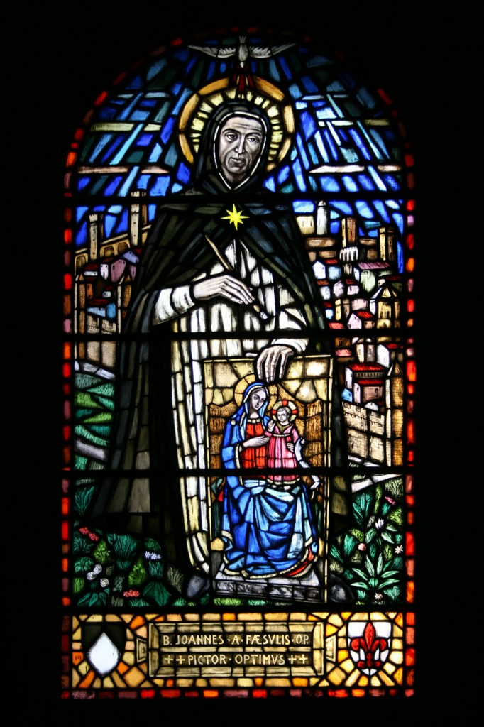

Bl. John of Fiesole
Friar, Painter, “Fra Angelico”
Born: 1395, Died: February 18 1455
Attributes: Paint Brush, Color Palette, Dominican Habit

Biography
Bl. John of Fiesole, popularly known as Bl. Fra Angelico, was a Dominican painter in the mid-fifteenth century known for the beauty of his paintings and the holiness of his priestly life. Nicknamed “Angelico” by his brothers, his Dominican consecration and life are worthy of imitation as he preached Jesus Christ by his life, his words, and his paintings. Given the name Guido at Baptism, this saint was born near Vicchio, in the vicinity of Florence, at the end of the 14th century. From his youth he practiced the art of painting. Having entered the Dominican convent in Fiesole, he was given the name Brother Giovanni (Brother John). After ordination he held various responsibilities, one of which was that of prior of the convent in Fiesole.

Faithful to the promises he made as a Dominican, to preach the Gospel after having contemplated it in prayer, Fra Angelico put his creativity at the disposal of the Lord. With brush and paint in hand, he used his talents to transmit to all people the sublimity and the redemptive strength of the divine mysteries. Between 1425 and 1447, Fra Angelico carried out his activity for the Dominican convents and other ecclesiastical institutes at Fiesole, Florence (most especially at the convent of San Marco), Cortona and Orvieto. The fame of his genius merited him the esteem of the Sovereign Pontiffs Eugenio IV and Nicolas V, who contracted him for the task of frescoing several rooms in the Vatican Palace (1445-49).

Fra Angelico died on February 18, 1455, in the convent of Santa Maria Sopra Minerva in Rome and was buried in the adjoining Basilica, where his body was covered by a simple slab on which was carved his portrait. With a personality that was uncomplicated and clear, Brother Giovanni had lived a poor and humble life, refusing honors and positions.

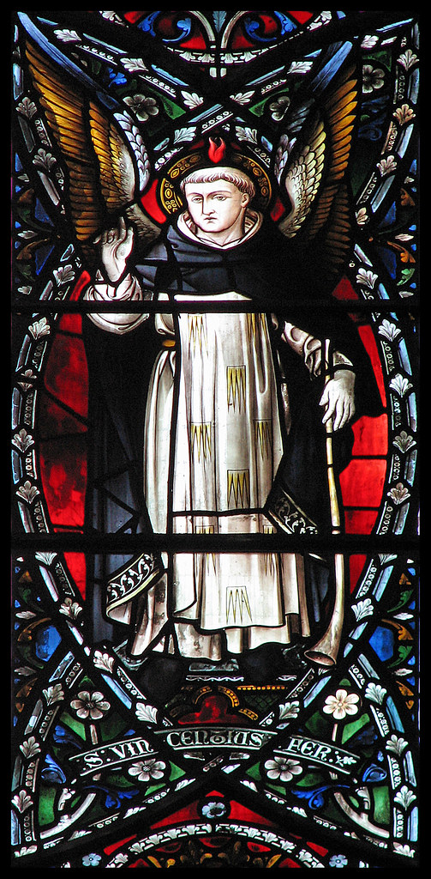
St. Vincent Ferrer
Friar, Priest, “Preacher of the Apocalypse”
Born: January 30 1350, Died: April 5 1419
Attributes: Trumpet, Wings, Book, Index finger pointing upward

Biography
St. Vincent Ferrer's father was an Englishman, who had been knighted at the siege of the city. On February 5th, 1367, having completed his studies in philosophy, he became a Dominican. He was moved to Barcelona in the next year, and in 1370 became lecturer in philosophy at the Dominican house in Lerida. In 1373, when he returned to Barcelona to the 'Studium Arabicum et Hebraicum', he was already a famous public preacher.

In 1377 he was sent to Toulouse for further study; there he attracted the attention of the Legate of the future Avignon antipope, Cardinal Pedro de Luna, whose suite he joined, being himself a strong advocate of the claims of the Avignon popes as against those of Rome. He preached a great deal, particularly to Jews and Moors, and converted a rabbi of Valladolid, who, later became Bishop Paul of Burgos, and associated with St. Vincent in his strenuous and successful attempts to convert the Jews of Spain.

Disillusioned in his attempts to heal the schism between Rome and Avignon, St. Vincent saw a vision of our Lord standing between St. Dominic and St. Francis, commissioning him directly to go about preaching penance. He was released by Benedict XIII in November 1399 to do this, and continued his preaching and wandering throughout western Europe until his death, being followed by a crowd of penitents and flagellants which varied from 300 to 10,000. He was in Aragon when the throne became vacant and with his brother, Boniface, a Carthusian, was instrumental in choosing Ferdinand of Castille as prince.

In 1416 he withdrew his own allegiance and that of the kingdom of Aragon from Benedict XIII, because the Avignon antipope had made no serious attempt to heal the schism and had refused the request made by the council of Constance that he should resign in order to make possible a new and undisputed election to the papacy. St. Vincent's decision had the effect of deposing Benedict and of making possible an end to the schism. St. Vincent died on April 5th, 1419, at Vannes in Brittany, where his relics are venerated. He was canonized by Pope Calixtus II in 1455.

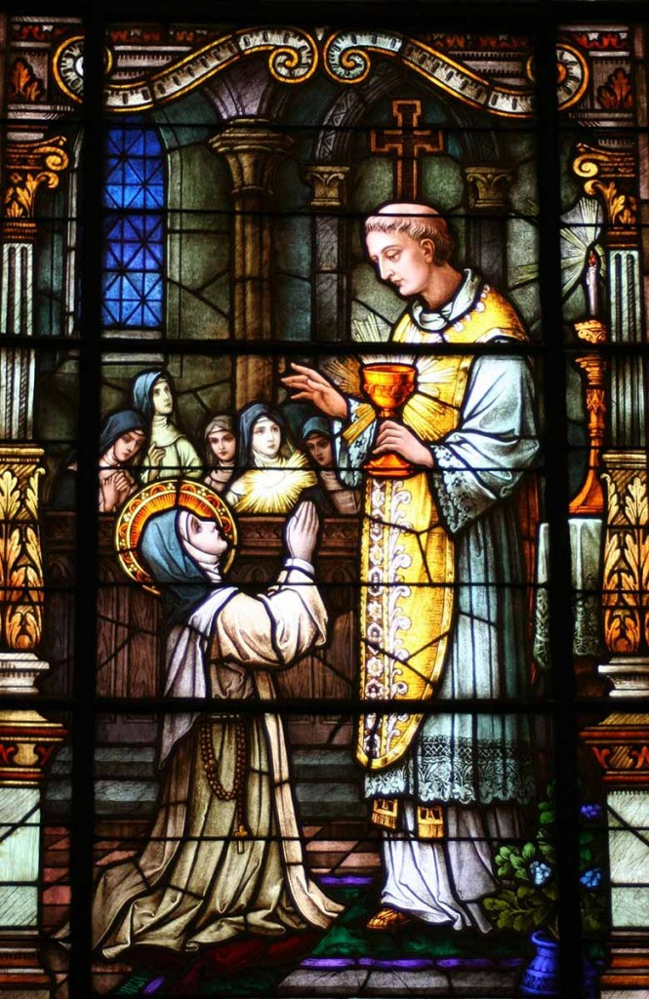

Bl. Imelda Lambertini
Nun, Virgin
Born: 1322, Died: May 13, 1333
Attributes: Sacred Host, Flowers on Head, Young Aura

Biography
When Imelda was nine, she asked to be allowed to go to the Dominicans at Val di Pietra. She was the only child of a couple old enough not to hope for any more children; it was a wrench to let her go. However, they took her to the convent and gave her to God with willing, if sorrowing, hearts. Imelda’s status in the convent is hard to discern. She wore the habit, followed the exercises of the house as much as she was allowed to, and longed for the day when she would be old enough to join them in the two things she envied most–the midnight Office and the reception of Holy Eucharist. Her age barred her from both. She picked up the Divine Office from hearing the sisters chant, and meditated as well as she could. It was a lonely life for the little girl of nine, and, like many another lonely child, she imagined playmates for herself–with this one difference–her playmates were saints. She was especially fond of Saint Agnes, the martyr, who was little older than Imelda herself. Often she read about her from the large illuminated books in the library, and one day Agnes came in a vision to see her. Imelda was delighted.
Shut away from participation in adult devotions, she had found a contemporary who could tell her about the things she most wanted to know. Agnes came often after this, and they talked of heavenly things. Her first Christmas in the convent brought only sorrow to Imelda. She had been hoping that the sisters would relent and allow her to receive Communion with them, but on the great day, when everyone except her could go receive Jesus in the Eucharist, Imelda remained in her place, gazing through tears at the waxen figure in the creche. Imelda began to pray even more earnestly that she might receive Communion.When her prayer was answered, spring had come to Bologna, and the world was preparing for the Feast of the Ascension. No one paid much attention to the little girl as she knelt in prayer while the sisters prepared for the Mass. Even when she asked to remain in the chapel in vigil on the eve of the feast, it caused no comment; she was a devout child. The sisters did not know how insistently she was knocking at heaven’s gate, reciting to herself, for assurance, the prayer that appeared in the Communion verse for the Rogation Days: “Ask and it shall be given to you, seek and you shall find, knock and it shall be opened to you.” The door was opened for Imelda on the morning of the Vigil of the Ascension. She had asked once more for the great privilege of receiving Communion, and, because of her persistence, the chaplain was called in on the case. He refused flatly; Imelda must wait until she was older. She went to her place in the chapel, giving no outward sign that she intended to take heaven by storm, and watched quietly enough while the other sister went to Communion.
After Mass, Imelda remained in her place in the choir. The sacristan busied herself putting out candles and removing the Mass vestments. A sound caused her to turn and look into the choir, and she saw a brilliant light shining above Imelda’s head, and a Host suspended in the light. The sacristan hurried to get the chaplain. The chaplain now had no choice; God had indicated that He wanted to be communicated to Imelda. Reverently, the chaplain took the Host and gave it to the rapt child, who knelt like a shining statue, unconscious of the nuns crowding into the chapel, or the laypeople pushing against the chapel grille to see what might be happening there. After an interval for thanksgiving, the prioress went to call the little novice for breakfast. She found her still kneeling. There was a smile on her face, but she was dead.

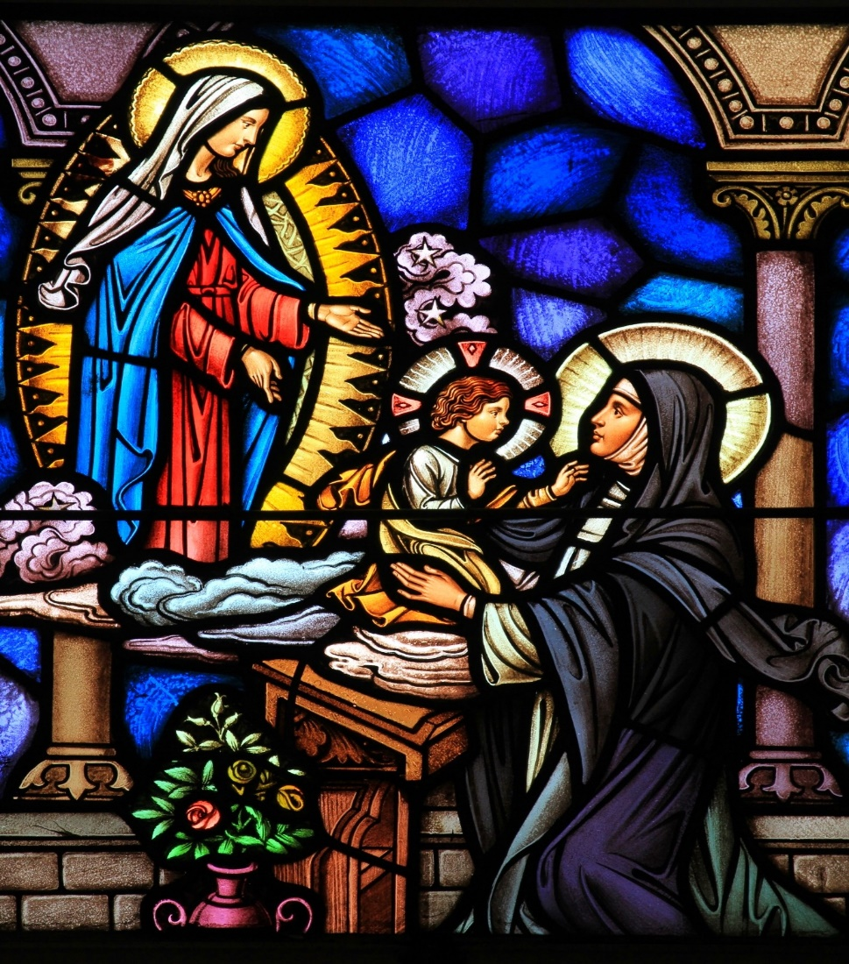

St. Agnes of Montepulciano
Nun, Virgin, Prioress
Born: January 28 1268, Died: April 20 1317
Attributes: Crucifix, Lily, Lamb, Child Jesus

Biography
St. Agnes of Montepulciano became well-known for the supernatural signs that accompanied her growth in holiness.She was born 1268 to a wealthy family. She joined the convent in her hometown as a very young girl, and vigorously applied herself to prayer and formation. She was wise, even as a youth, and was entrusted with the role of housekeeper for the convent when she was 14. When a new convent was opened nearby, Agnes was among those who departed to help begin the new community. She inspired a number of other young women to join that new convent, and she was chosen to lead the community as abbess.

She was only 15 and had to receive special permission from the pope to take on that role at such a young age.With such a great responsibility at hand, Agnes practiced a strict discipline with herself—for the next 15 years, she lived on bread and water alone and slept on the ground with a stone for a pillow. Only when she faced a serious illness did she relent these disciplines. She became well-known for her holiness, and special signs accompanied her prayer. She received several visions—holding the infant Jesus in her arms at one point, and receiving Communion from an angel in another. The nuns in her community saw her lifted two feet off the ground when she was praying. When the convent ran out of food, she could feed the whole community with a handful of bread after she had blessed it.

Most interesting of all, though, was the appearance of manna about her body when she prayed. She would sometimes be consumed in rapturous prayer, and a white, frosty-looking manna would appear on her cloak and in the place where she was kneeling. Her sisters reported that in these instances she looked like she had been outside in a heavy snowstorm. The people of her hometown, Montepulciano, wanted her to return to them, so she returned to found a new convent and asked that it be placed under the order established by St. Dominic. They built the convent building on a site that had previously held a brothel. She lived at this new convent until she died, and served as its prioress. Signs of holiness continued to follow her, including prophecies and healings—she miraculously resuscitated a child who had drowned. The community thrived under her guidance until she fell gravely ill at the age of 49.When it was clear that she would die, her community became distressed, and she told them, “If you loved me, you would be glad because I am about to enter the glory of my Spouse. Do not grieve over my departure—I shall not lose sight of you. You will find that I have not abandoned you.”

Her tomb became a pilgrimage site, and Agnes’ body remained incorrupt there. The great St. Catherine of Siena visited her tomb, and it is said that when she bent down to kiss the foot of Agnes’ body, it lifted itself to meet her lips.

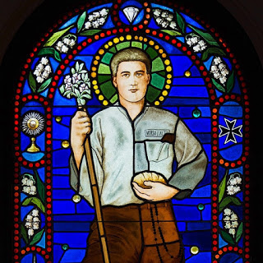
Bl. Pierre Frassati
Lay Dominican
Born: April 6 1901, Died: July 4 1925
Attributes: Lay Dominican Scapular, Fine Casual Wear

Biography
Born in Turin in 1901 to a well-known affluent Italian family, Pier Giorgio grew steadily and deeply in the graces of his baptism, despite quite a few challenges surrounding him. His father, an agnostic, was the founder and publisher of a liberal Italian newspaper. His mother, more sensitive and artistic by nature than her husband, saw to the religious upbringing of Pier Giorgio and his younger sister, but she worried as the boy grew older that he was becoming unnecessarily “extreme” in his personal devotion to the sacraments, prayer, and acts of charity. The lived expression of his Catholic faith, however, continued to mature in Pier Giorgio as he himself matured, and God’s grace built firmly on his lively, sensitive nature. The fact that his parents did not understand this was often a source of personal struggle for the boy. He loved his parents deeply, and the strain he saw developing in their marriage was a great source of sorrow for him as he grew older. Pier Giorgio was educated first at home, then at a state school, and finally in a Jesuit run institution.
While cultivating a natural love for beauty and the arts, he often found formal studies difficult, much to the disappointment of his success driven father. As a teenager, Pier Giorgio became involved in both spiritual organizations open to students and groups devoted to active works of mercy among the poor. Increasingly, we are told, devotion to the Holy Eucharist and to the Blessed Virgin Mary were the focus of his prayer. He began to develop a deep spiritual life, which he was never embarrassed to share with his friends. His love for God fed his devotion to the service of the poor and needy, and even drove him to political activism in support of the Church’s social teaching. A young man with a vast capacity for both leadership and friendship, Pier Giorgio inevitably influenced the young people in his circle.
Not only was he the instigator of practical jokes and fun, but he also sought to draw them unashamedly to love God and live their faith. Pier Giorgio delighted in serving the poor, and looked upon his involvement in their lives as a privilege. His own parents often misunderstood the “excess” in him as an obstacle to his future and a sign of lack of ambition. We are told that Pier Giorgio at one point made the decision to forgo the pure and tender love he felt for a young woman his age, because he knew their relationship would be cause for further tension within his own family. At the age of 21, Pier Giorgio furthered his spiritual aspirations by becoming a member of the Dominican Laity. Here he found encouragement for his Eucharistic and Marian devotion, and further outlets for his works of mercy. Shortly before he was to receive his degree, Pier Giorgio contracted a severe case of polio, probably caught from the sick to whom he ministered.
He neglected his own health because his grandmother was dying, and that after six days of intense suffering he died on July 4, 1925. His own family had not suspected how ill he was. Pier Giorgio’s funeral was also a revelation to his family. The poor and needy whom he had served for so many years of his short life turned out in droves to mourn him. For their part, these poor were surprised to find out that this saintly young man who had been so solicitous for them was the son of such an influential family. Pope John Paul II remarked in 1989, after visiting the tomb of Pier Giorgio, that he also had felt in his own youth “the beneficial influence of his example.” “He left the world rather young,” he said, “but he made a mark upon our entire century.”

